2020 PPLO MEMBERSHIP FORM

Name _____________________________________________________________
Address ___________________________________________________________
City_________________________ State____________________ Zip_________
Phone _____________________________________ Age____________________
Email______________________________________________________________
Gender _____ Pro_____ College______________________________________

If you are not currently competing at the college level for a college or university woodsman’s team, please mark “PRO.” If you are a collegiate competitor, please name your school.

Make checks payable to: PA Professional Lumberjack Organization

MAIL FORM & CHECK TO:
Rene Miller | Membership $30.00 each $_________
130 Mountain Ridge Rd | Donation Amount $_________
Morgantown, WV 26508 | TOTAL $_________

Membership is necessary to be eligible to win the overall award.
Membership forms must be paid and turned in (postmarked) by April 4th, 2020 to insure that you have a shirt by the first show Tuscarora Valley Heritage Days.

List of PPLO Shows
- Tuscarora Valley Heritage Days
- Loyalsock Valley Antique Machinery Show
- Perry County Fair
- PA Lumberjack Championships**
- Centre County Grange Fair
- Tioga County Fair
*these shows require a PPLO shirt and membership be paid. List of shows is subject to change
** PA Championships Organization provides shirts and a $10 membership fee to non-members if this is the only show you attend within the PPLO.

T- Shirt Order
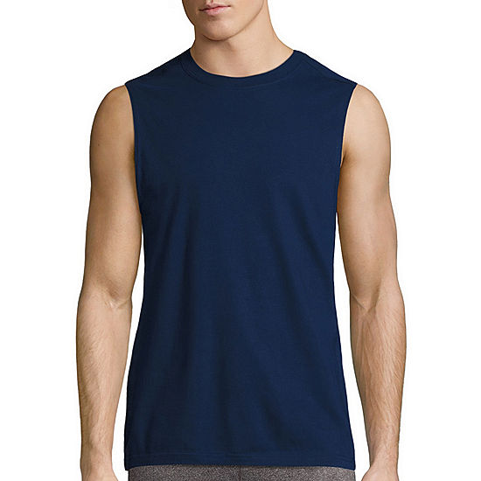
The shirts will be the same as the 2019 season shirts. They are men’s size shirts.
Shirt Size : ________
Regular t-shirt or sleeveless t-shirt (example to right)
Shirt Style:______________________

We are working on names on the back, please include a name for the back of the shirt and must be turned in on the April 4th, 2020 date to get your name included on the shirt.
Shirt Name :__________________________________

If you would like any additional shirts they will be $15 each for either style of shirt.
Additional shirts : Quantity ____________Size _____________Style ________________
Quantity ____________Size _____________Style ________________
Quantity ____________Size _____________Style ________________

