The 38th Annual Sullivan County Fall Festival, Lumberjack Competition
Event held at: The Sullivan County Fairgrounds 4430 Rte 154 Forksville, PA 18616
Saturday October 13th and 14th 2018
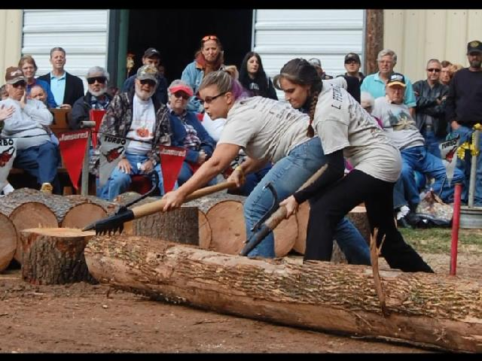
Dear Competitors, send your registration in early, Pre-registration helps us know in advance how much wood we need to provide for each competition. Special Lumberjack Competition T-shirts will be guaranteed to those competitors who pre-register.
Don’t forget to mark your size preference on your registration form. Our best efforts will be to meet your size request. Anyone who does not pre-register September 8th 2018, Event confirmations will be sent to email addresses that are marked on the registrations. Please Print Clearly.

The registration table will open at 8:15 am on Saturday and 9:30 am on Sunday. It is expected that you sign in as soon as you arrive. Changes to your entries can be made if wood is available. Sorry, but no refunds will be allowed.

Entry fee for each event still remains at $5 per person. Please mark your partner’s name on your registration form for (log rolling, cross cut saw, and Jack and Jill cross cut, and so on). Our best efforts will be made to help competitors find partners for any event. Put partner needed in the space for the name.

Free gate passes will be available to you. You can pick them up at the Chamber office located in the Red 4H building the morning of the event or if requested we can mail them to you before the event. This identifies you as a Lumberjack Competitor and will allow you free access to the event arena. Call or email me or call the Chamber office at 570-482-4088 if you have any questions concerning this event.

We hope that you had a great summer and we look forward to seeing you in October.

Sincerely,
Sean Frantz
538 Dutchtown Road
Muncy, Pa 17756
sean1100rem@yahoo.com
570-772-4989
The 38th Annual Sullivan County Fall Festival, Lumberjack Competition
Saturday October 13th and Sunday October 14th, 2018
RELEASE
I, The Releaser, in consideration of being permitted to participate in the Lumberjack Competition being conducted at the Fall Festival in Sullivan County, Pa, do for myself, my heirs, executors, administrators and assigns, hereby release , hold harmless and forever discharge the Sullivan County Fall Festival, The Sullivan County Chamber of Commerce, The Sullivan County Fair Association, and Lumberjack Competition organizers and sponsors, their officers, agents and employees of any and from every claim, demand, action, or right of action, of whatever kind or nature, either in law or in equity, arising from or by reason of bodily injury or personal injuries, known or unknown, death or property damage resulting or to result from any accident which may occur as a result of participation in the Lumberjack Competition or any activities as a result of participation in the Lumberjack Competition or any activities in connection with the Lumberjack Competition, , whether by negligence or not. I further release the Sullivan County Chamber of Commerce or the Sullivan County Fair Association from any claim whatsoever on account of first aid treatment, or services rendered to me during participation in the Lumberjack Competition. I, The Releaser further state that I have carefully read the foregoing Release and know the content thereof and sign this Release of my own free act.

Date ________________________________________ Name__________________________________

Signature_____________________________________________ Address_________________________________
Releaser

Email Address________________________________________ ________________________________________

Phone Number______________________________________ T-shirt Size: Med, Large X-large XX-Large
T-shirts will be guaranteed to pre-registrants only
Registration Note: Registration open at 8:15 am on Saturday and 9:30 am on Sunday
Entry fee is $5.00 per event per person
Saw Obstacle participants MUST be pre-registered prior to event date
Mail checks payable to: Sullivan County Chamber of Commerce Po box 134, Muncy Valley, PA 17758
Name of Event Mark Event List Partner’s Name Please print clearly

Log Roll-Men_________________________________________________________________________
Log Roll-Women ______________________________________________________________________
Cross Cut Saw-2 person Men___________________________________________________________
Cross Cut Saw-2 person Women_________________________________________________________
Jack-n-Jill Crosscut ____________________________________________________________________
One Man Bucking Men________________________________________________________________
One Women Bucking, Women____________________________________________________________
Underhand Chop-Men _______________________________ _ Amount Paid__________________ __
Underhand Chop-Women_____________________________ Check Number _____________________
Hot Saw M/W combined_________________________________________________________________
Maynard Kenneth Reibson Axe Throw M/W combined_________________________________________
Spring Board-Right/Left_________________________________________________________________
Sunday Only –Chainsaw Obstacle Course__________________________________________________

